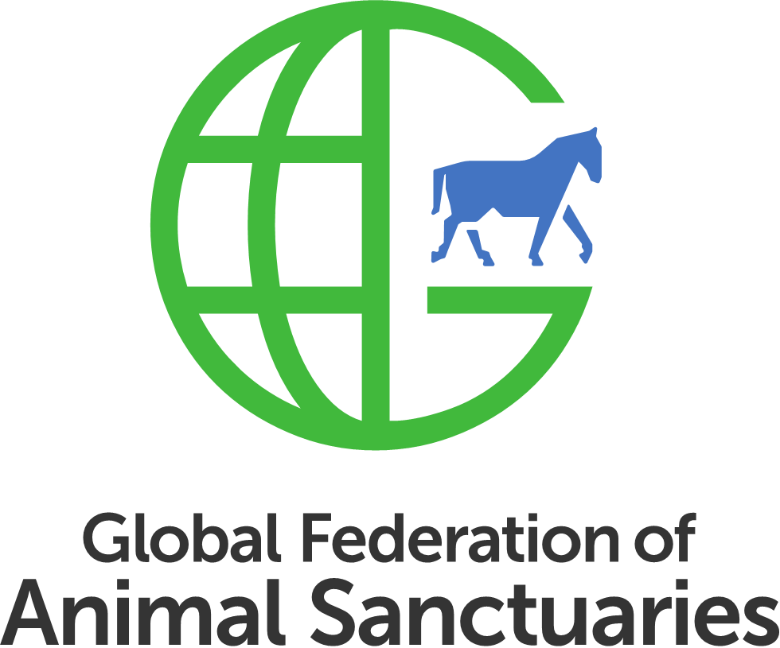
Required Documents for Accreditation/Verification- Equine and Farm
Please NOTE: We recognize that not all facilities have the listed items as separate documents, but that rather they are included in other manuals or folders, in hard or electronic copy. We also understand that some categories of documents may differ by country, and we will work with you if you need assistance in drafting a document. If you have questions about what is needed, please look to the templates and samples that we have made available or if you need more samples, please send an email to contact@sanctuaryfederation.org . We are here to support you and help you through the process to make it as easy as possible for you.
There are sample documents and templates for many of the items listed below. You can download the samples here.
Submitted |  | Needed for Verification | Needed for Accreditation
 | Facilities and Staffing
 | - Labeled map of layout of each facility location (can be hand drawn or Google/MapQuest/Zillow | ✓ | ✓
 | - Organizational chart |  | ✓
 | - Training and supervision protocols for employees, volunteers, and interns (do not need to submit separately if submitted as part of other manuals/SOPs) |  | ✓
 | Governing Authority
 | - Proof of non-profit, non-commercial, or equivalent status | ✓ | ✓
 | - Proof of US State Charity Registrations as required by state law (and to solicit contributions in that state) | ✓ | ✓
 | - Proof of land ownership or copy of leasing or other agreement for each facility location | ✓ | ✓
 | - Lease Contingency plan for each location, if property is not owned by sanctuary or governing organization | ✓ | ✓
 | - Job descriptions for key personnel (sanctuary manager and/or executive director) |  | ✓
 | - List of Board of Directors/Trustees | ✓ | ✓
 | - One set of Board Minutes |  | ✓
 | - Copy of current licenses and permits required by law | ✓ | ✓
 | - Bylaws (or equivalent document) and amendments |  | ✓
 | - Succession plan |  | ✓
 | - Strategic plan (3 year) including financial plan |  | ✓
 | - Governance Policies:
 | - Grievance policy |  | ✓
 | - Whistleblower policy |  | ✓
 | - Code of Conduct/Ethics |  | ✓
 | - Anti-discrimination policy |  | ✓
 | - Conflict of interest policy |  | ✓
 | Financial and Risk Management
 | - Most recent tax document filed to maintain non-profit status, if applicable (example: IRS Form 990 in the U.S.) | ✓ | ✓
 | - Current fiscal year annual operating budget | ✓ | ✓
 | - Proof of separate organization or facility bank account (such as voided check or bank statement) | ✓ | ✓
 | - Proof of General/Public Liability Insurance Coverage (unless not available in country) | ✓ | ✓
 | - Proof of Management Liability/ Directors and Officers Insurance Coverage (unless not available in country) |  | ✓
 | - Proof of designated funds for emergencies (at least 3 months for Accreditation, at least one month for Verification) available to cover operating costs. | ✓ | ✓
 | - Most recent Statement of Revenue and Expenses |  | ✓
 | Safety
 | - Disaster preparedness/emergency plan | ✓ | ✓
 | - Escaped animal plan | ✓ | ✓
 | - Firearm policies, unless N/A | ✓ | ✓
 | - Human first aid plan | ✓ | ✓
 | - Written Standard Operating Procedures or manual regarding animal care | ✓ | ✓
 | Animal Care
 | - Preventative medicine program, including zoonotic disease policy- schedule of vaccinations, parasite control, dental care, foot/hoof care | ✓ | ✓
 | Education/Public Access/Advocacy
 | - Education and outreach policy unless N/A |  | ✓
 | Acquisition/Disposition
 | - Adoption policies/requirements/contracts unless N/A | ✓ | ✓
 | - Foster policies/requirements/contracts unless N/A | ✓ | ✓
 | - Acquisition policy and Disposition policy including Euthanasia policy |  | ✓
 | Human Resources
 | - Employee manual, if applicable |  | ✓
 | - Volunteer/Intern manual, if applicable |  | ✓
 | For U.S. Based Equine Groups
 | - If organization participated in most recent Equine Welfare Data Collective survey, please confirm | ✓ | ✓

