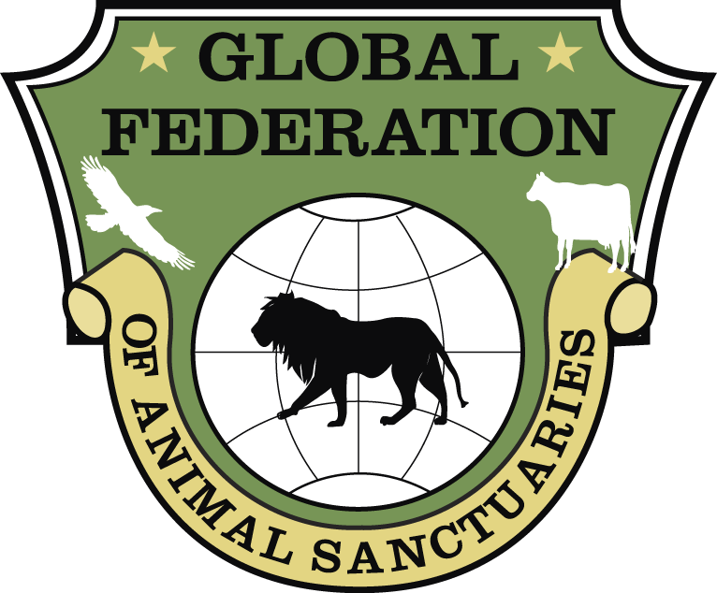

Global Federation of Animal Sanctuaries (GFAS) Policy on
Suspension or Revocation of Accredited or Verified Status

Suspending or Revoking Accredited or Verified Status

In certain circumstances, Accredited or Verified status may be suspended or revoked by GFAS, if GFAS concludes that its standards are not being consistently met and maintained. Decisions to suspend or revoke GFAS Accreditation or Verification will be made by the Accreditation Committee, and may occur in circumstances including, but not limited to, the following:

- GFAS has received a complaint about the organization and the organization either fails to respond to notice from GFAS about the complaint or to cooperate in GFAS’ investigation of the complaint.
- GFAS has learned that the organization has been cited by a national, state/province or local authority for noncompliance with legal or regulatory requirements.
- GFAS has learned that the facility has lost a necessary operating license or has lost nonprofit status.
- Allegations in a complaint are sufficiently serious (such as animal abuse or unethical conduct by the Executive Director), even if the organization has cooperated with GFAS after receiving notice of the complaint and has put a plan in place to remedy the areas of noncompliance.
- A facility has been without the services of a permanent CEO/Executive Director for longer than six (6) months.

- Significant facility damage that impacts facility functions (e.g. fire, natural disaster).

When GFAS makes a determination to suspend or revoke a facility’s Accredited or Verified status, it will notify the organization in writing and will request that the organization remove all reference to GFAS Accreditation or Verification, including the GFAS logo, from its website and written materials (including materials used for fundraising). GFAS will remove the facility’s listing from the GFAS website.

If a facility’s GFAS status has been suspended, GFAS will reinstate its status upon receiving evidence from the facility that it has made substantial progress under the plan that has been approved by the Accreditation Committee. Upon reinstatement, GFAS will return the facility’s name to the listing of Accredited and Verified organizations listed on its website, and will notify the facility that it may again identify itself as GFAS Accredited or Verified and use the appropriate GFAS logo.

If a facility’s GFAS status has been revoked, the sanctuary may re-apply for GFAS Accreditation or Verification after a year has passed from the date of revocation. During that time, GFAS may offer to provide resources and logistical advice to the facility to assist it in taking the necessary steps to cure its areas of noncompliance.

Relocation Assessment

In the event of a move, GFAS will suspend certification status until a new facility has been assessed. However, in this case, the organization will remain listed on the GFAS website as “relocation assessment in process.” The organization will have one year to begin a new assessment before being removed from the website.

Updated Feb. 2016

